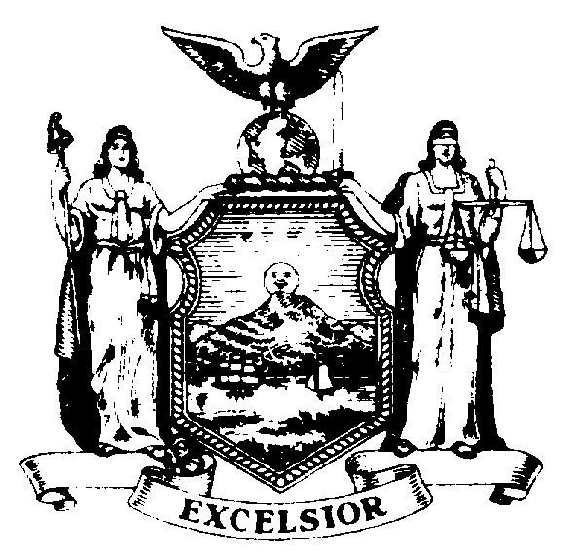
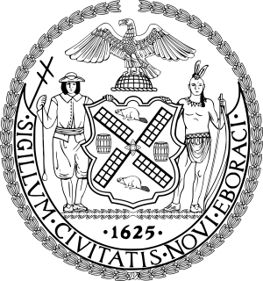

February 15, 2018
MTA New York City Transit
Andy Byford, President
2 Broadway
New York, NY 10004

Dear Mr. Byford,
We write to oppose the plans for the Station Renewal construction project at Ditmars Boulevard unless it includes accessibility upgrades and service improvements.

Our community agrees – over 850 New Yorkers have already signed our petition to oppose the construction.

Residents and small business owners will have to endure sidewalk congestion, intermittent weekend closures, noise, loss of parking, and traffic from the construction materials and equipment that will be stored on 31st Street throughout the entire 14-month renovation. Small business owners are understandably worried that they will lose business as a consequence of the construction hurting visibility of their shops and restaurants, eliminating parking spots and increasing sidewalk congestion.

We understand the station is old and needs repair work, but the MTA must take this opportunity to make long-term infrastructure updates to the station. These infrastructure updates should include making the station accessible in compliance with the federal Americans with Disabilities Act (ADA) as well as track work and signal upgrades to improve subway service.

Our community is already suffering the effects of the ill-advised Enhanced Station Initiative that has closed the 30th Avenue and 36th Avenue stations at a great cost for cosmetic upgrades.

As there are currently no elevators along any of the N/W stations in Western Queens, ADA accessibility is needed by people with disabilities, parents with strollers, and seniors. Commuters across Astoria are in dire need of service improvements as subway delays and signal failures are now an everyday occurrence.

The MTA has shown a blatant disregard for our community and its representatives during this process. There has been no opportunity to collect public input. Elected officials and the community board were informed about the project only two months before the planned start. The authority did not provide any written notification or written information to the community board or to elected officials.

If the MTA does not comprehensively address infrastructure along our subway lines with long-term improvements including modernized signals and accessibility upgrades, it will continue to fail Astoria residents.

Sincerely,
State Senator Michael Gianaris, 12th Senate District
State Assemblymember Aravella Simotas, 36th Assembly District
City Council Member Costa Constantinides, 22nd Council District

