The Council of the City of New York

Hon. Corey Johnson
Speaker of the Council

Hon. Joseph Borelli
Chair, Committee on Fire and Emergency Management

Report of the Finance Division on the
Fiscal 2022 Preliminary Plan and the
Fiscal 2021 Preliminary Mayor’s Management Report
Fire Department of New York
March 19, 2021
Finance Division
Jack Kern, Financial Analyst
Eisha Wright, Unit Head
Latonia McKinney, Director Nathan Toth, Deputy Director
Regina Poreda Ryan, Deputy Director Paul Scimone, Deputy Director
Table of Contents
Fire Department of New York Overview 1
FDNY Fiscal 2022 Preliminary Budget: Expense 2
Agency Budget Summary 3
Agency Funding 8
Fiscal 2021 City Council Priorities 13
Miscellaneous Revenue 17
Fiscal 2021 Preliminary Mayor’s Management Report 18
Contract Budget 19
Fiscal 2022-2025 Preliminary Capital Budget 20
Preliminary Capital Commitment Plan for Fiscal 2021-2025 20
Preliminary Ten-Year Capital Strategy Fiscal 2022-2031 22
Appendices 24
A: Budget Actions in the November and the Preliminary Plans 24
B: FDNY Contract Budget 25
C: Program Areas 26
Fire Extinguishment/Emergency Response 26
Emergency Medical Services 27
Executive Administrative 28
Fire Prevention 29
Fire Investigation 30

Fire Department of New York Overview
The Fire Department (FDNY or Department) responds to fires, public safety and medical emergencies, natural disasters, and terrorist acts to protect City residents’ and visitors’ lives and property. The Department advances fire safety through its fire prevention, investigation and education programs, and contributes to the City’s homeland security efforts. In addition to responding to more than 300,000 fires and non-fire related emergencies and more than 1.5 million medical emergencies a year, the FDNY maintains approximately 250 firehouses and ambulance stations.
FDNY’s budget totals $2.09 billion for Fiscal 2022. Moreover, it includes five Unit of Appropriation (U/A) pairs, which generally represent the functions of the Department. In this report each U/A pair is referred to as a program area, analogous to the program areas of agencies included in the Budget Function Analysis report prepared by the Office of Management and Budget. Each pair includes a personal services (PS) and other than personal services (OTPS) U/A. Each U/A and service goal is outlined below. The Fire Department’s five service areas are extensive and aim to address fire and emergency medical response in the five boroughs.

FDNY Fiscal 2022 Preliminary Budget: Expense
The Fire Department’s Fiscal 2022 Preliminary Budget is $2.09 billion, with $1.86 billion or 89 percent for PS and $228 million or 11 percent for OTPS. The Fire Department’s budget has been growing year after year, with actual Fiscal 2020 expenditures $240 million greater than Fiscal 2016. Due to the COVID-19 pandemic and the City’s subsequent budget reduction, the Department made specific programmatic and budgetary changes to reduce its City funded budget while simultaneously increasing spending on pandemic-related programs that have been largely supported with federal aid. Due to the nature of the FDNY’s mission, it has seen increases of federal funds from the Federal Emergency Management Agency (FEMA) for firefighter overtime, hotel rooms for emergency responders who cannot socially distance at home, and other reimbursable spending. The Department also received funding from the Coronavirus Aid, Relief, and Economic Security Act (CARES), with FEMA funding, the Department’s budget has grown.

The Fire Department remains a service-oriented agency, with nearly 90 percent of funding supporting personal services, namely salaries to uniformed members. The chart shows spending over time, specifically that PS has consistently been the largest category for the FDNY.
The Fire Department’s budget accounts for more than two percent of the City’s budget with approximately $2.1 billion annually to support the Department’s public safety efforts. The Department employs more than five percent of the City’s workforce with 17,000 firefighters, Emergency Medical Technicians, paramedics, fire inspectors, dispatchers, and more. Approximately one in every five of the City’s uniformed employees are firefighters, and roughly 65 percent of FDNY’s staff are uniformed.
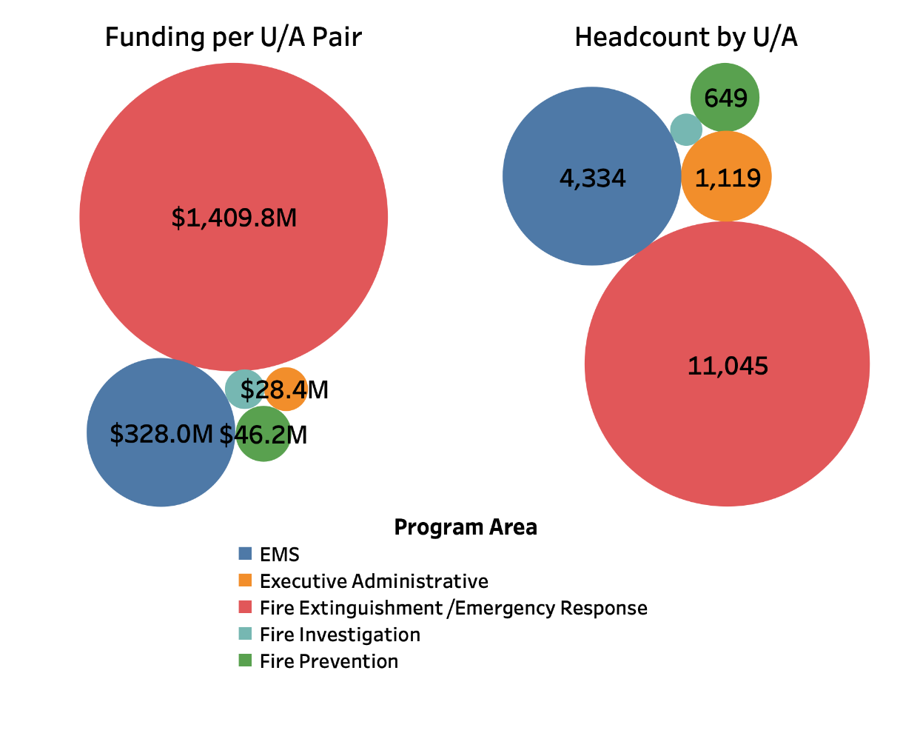
The Department’s funding primarily supports Fire Extinguishment and Emergency Response with more than 11,000, or 60 percent, of the total 17,288 budgeted positions for Fiscal 2022, as well as $1.4 billion, or 67 percent of the Department’s funding. The chart below shows the breakdown by program area, with both funding and headcount. The charts visualizes that each program area roughly aligns by size of budget and number of employees.
*Fire Investigation not labeled. Funding $23.3 million and 141 Positions

The Preliminary Financial Plan for Fiscal 2021-2025 (the Plan or the Preliminary Plan) projects slightly lower spending, $12 million, or less than one percent less, in Fiscal 2022 as compared to the Adopted Fiscal 2022 Budget reductions associated with the Fly Car program and PS Savings drive the change. Fire Extinguishment and Emergency Medical Services (EMS) experience the largest decreases, by $14 million and $3 million, respectively, while Executive Administrative and Fire Investigation increase by $5 million and $640,000, respectively.

Agency Budget Summary
The table below outlines FDNY’s actual budgets for Fiscal 2019 and 2020, the Fiscal 2021 Adopted budget, the Fiscal 2021 current budget, and the Fiscal 2022 Preliminary Budget. Included are the Fiscal 2021 Adopted Budget’s difference compared to the Fiscal 2022 Preliminary budget and the funding sources.

FDNY Financial Summary
Dollars in Thousands
 | FY19 | FY20 | FY21 | Preliminary Plan |  | *Difference
 | Actual | Actual | Adopted | FY21 | FY22 | FY21-FY22
Budget by Program Area
Fire Extinguishment/ Emergency Response | $1,401,134 | $1,402,896 | $1,423,788 | $1,409,002 | $1,409,818 | ($13,969)
Emergency Medical Services | 332,182 | 343,120 | 330,646 | 327,971 | 327,983 | (2,663)
Executive Administrative | 304,395 | 353,931 | 279,293 | 352,823 | 284,188 | 4,895
Fire Prevention | 50,173 | 50,180 | 47,133 | 46,698 | 46,208 | (925)
Fire Investigation | 26,144 | 24,370 | 22,699 | 23,417 | 23,342 | 643
Total | $2,114,028 | $2,174,497 | $2,103,558 | $2,159,910 | $2,091,540 | ($12,019)
Funding
City Funds |  |  | $1,727,102 | $1,694,869 | $1,662,291 | ($64,810)
Other Categorical |  |  | 327,304 | 343,311 | 376,204 | 48,900
Capital- IFA |  |  | 567 | 564 | 567 | 0
State |  |  | 1,835 | 2,144 | 1,835 | 0
Federal - Other |  |  | 46,746 | 118,302 | 50,637 | 3,892
Intra-City |  |  | 6 | 719 | 6 | 0
Total | $2,114,028 | $2,174,497 | $2,103,558 | $2,159,910 | $2,091,540 | ($12,019)
Budgeted Headcount
Full-Time Positions - Uniform | 11,244 | 11,047 | 10,943 | 10,945 | 10,945 | 2
Full-Time Positions - Civilian | 6,093 | 6,366 | 6,298 | 6,341 | 6,343 | 45
Total | 17,337 | 17,413 | 17,241 | 17,286 | 17,288 | 47
*The difference of Fiscal 2020 Adopted Budget compared to Fiscal 2021 Preliminary Budget.
FDNY Funding by Program Area
Most of the Department’s funding is PS, and most of the PS funding is spent on the Fire Extinguishment and Emergency Response U/A pair. The program area pie chart to the right shows the allocation of FDNY funding by program area.

Funding by Program Area  Dollars in Millions | 2020 Actual | 2021 Adopted | 2021 January | 2022 January | Difference
Fire Extinguishment/ Emergency Response | $1,403 | $1,424 | $1,409 | $1,410 | ($14.0)
Emergency Medical Services | 343.1 | 330.6 | 328.0 | 328.0 | (2.7)
Executive Administrative | 353.9 | 279.3 | 352.8 | 284.2 | 4.9
Fire Prevention | 50.2 | 47.1 | 46.7 | 46.2 | (0.9)
Fire Investigation | 24.4 | 22.7 | 23.4 | 23.3 | 0.6
Total | $2,174.5 | $2,103.6 | $2,159.9 | $2,091.5 | ($12.0)
FDNY Funding by Program Area
Outyear planning shows the Department’s budget has a net increase of $1.2 million into Fiscal 2024, with a $14.8 million increase to EMS, $2.6 million to Fire Extinguishment, and a $16.2 million reduction to Executive Administrative. As the Department continues to receive more medical calls year after year EMS will continue to become more important and funding will need to increase accordingly to keep services reliable. For example, the percentage of ALS Medical Emergencies responded to by ALS ambulances with a response time less than 10 minutes has decreased by six percent over the past five fiscal years from 57 percent to 51 percent. The outyear budgets for the Department hold steady at $2.1 billion annually, considering previous growth, holding steady at $2.1 billion is a change of pace.

The Fire Department’s fiscal outlook shows a stable budget around $2.1 billion annually. In reference to the City’s budget, the Fire Department is not following the City’s planned growth. The Department’s budget grows by close to zero percent from the Fiscal 2022 Preliminary Plan to Fiscal 2025, in contrast, the City’s budget grows by more than ten percent in the same time period.
Headcount is a different notion. The Department’s headcount is anticipated to grow from 17,350 positions in Fiscal 2022 to 17,613 in Fiscal 2025, with the majority of the growth in EMS from the Fly Car Program. At the same time the City’s workforce is anticipated to grow by 685 positions. The Fire Department will make up 38 percent of the City’s new positions between Fiscal 2022 and Fiscal 2025. From Fiscal 2022 to Fiscal 2025 the Department’s PS budget will grow by $19.5 million or approximately one percent, while the City’s PS budget will grow by $3.6 billion or seven percent over the same timeframe.
Preliminary Plan Changes
The Fiscal 2022 Preliminary Plan offers modest changes to the Department’s budget, net changes that increase the Department’s budget by $12.5 million in Fiscal 2021, $12.7 million in Fiscal 2022, $10.4 million in Fiscal 2023, with no changes to the outyears. The changes in this Plan are primarily federal additions from the Urban Area and Security Initiative (UASI), the State Homeland Security Grant, and fringe offset to replace City funds with federal funds. The fairly small changes in the short term are a result of the Fiscal 2022 Preliminary Plan, the outyear changes were already planned. Specific items from the Fiscal 2022 Preliminary Plan and November 2020 Plan are described below.
Since Adoption, the FDNY Budget has grown by $56 million in Fiscal 2021 and decreased by $7.3 million in Fiscal 2022. While the November 2020 Financial Plan included $43 million in Fiscal 2021 additions and $20 million in Fiscal 2022 reductions, this Plan increases spending estimates for both fiscal years. Highlights of the changes in the Fiscal 2022 Preliminary Plan are outlined below.
- CARES Act Funding Increase. As a health care entity, the Fire Department received funding from a grant that supports lost revenue due to COVID-19 and COVID-19 costs. The grant was distributed directly to the Health and Hospitals Corporation, and the FDNY is a sub-recipient of the funding, to support COVID-19 response. The Fire Department’s portion of the grant is $6.1 million in Fiscal 2021 only.
- EMS Mental Health Teams. The Preliminary Plan includes a total of $1.7 million to support a pilot program to change the way the City responds to mental health emergencies. This program will replace the typical police response. Ambulances staffed with two EMTs and one social worker will respond to mental health emergencies. The pilot program will be in Northern Manhattan, specifically East and Central Harlem, chosen because those are high need communities that the City and Department identified. This area had the most mental health calls in 2019, and the first 11 months of 2020, and the H+H hospitals, the East Harlem Support and Connection Center, and EMS facilities were all factors for the location. The total funding for the program is $1 million in Fiscal 2021 and $2.5 million in Fiscal 2022 split between the FDNY and H+H. FDNY’s portion is $511,000 in Fiscal 2021 and $1.2 million in Fiscal 2022, and will support 21 positions in each fiscal year 16 EMTs, three lieutenants, one captain and one Deputy Chief. The pilot is expected to launch this spring.
- State Homeland Security Grant 2020. Each fiscal year the Department receives funding from the federal government to support the ability to respond to acts of terror and other threats. The State Homeland Security Grant supports the Fire Department through capabilities-based, risk-driven, State Homeland Security Strategies to address homeland security priorities, by training and providing equipment to emergency responders. The Fiscal 2022 Preliminary Plan added $4.4 million in Fiscal 2021, $14.3 million in Fiscal 2022, and $5.9 million in Fiscal 2023. The Department received a similar total value and allocation by year in the Fiscal 2021 Executive Plan, $5.7 million in Fiscal 2020, $13.2 million in Fiscal 2021, and $6.7 million in Fiscal 2022. The past two fiscal years have included three-year allotments of SHSG funding, which differs from many other forms of federal funding that usually occur in the current fiscal year only. The lump sums allow the Department to plan spending appropriately. The Department also receives mid-year adjustments, usually increases, for various years of SHSG grants.
- Urban Areas Security Initiative 2020. The Urban Area Security Initiative (UASI) is a federal initiative unique to high-density, high-threat areas that is intended to improve regional preparedness to terror and other threats, by building a more secure and resilient nation. This funding improves the Fire Department’s ability to train and provide equipment for first responders and is a typical form of funding for the Department. The Preliminary Plan awarded $3.8 million in UASI funding to the FDNY in Fiscal 2021, and more than $17 million in the outyears. The Preliminary Plan added $3.8 million in UASI funding in Fiscal 2021, $13.2 million in Fiscal 2022, and $4.5 million in Fiscal 2023. The Fiscal 2021 Executive Plan added similar three-year funding through UASI, with $7.1 million in Fiscal 2020, $8.3 million in Fiscal 2021, and $1.2 million in Fiscal 2022. The Fiscal 2021 Executive Plan was the first time this three-year addition occurred, and allows for more accurate planning. The Department also receives adjustments in nearly every plan, usually increases, for various years of UASI grants.
The Plan introduced several savings that lowered the FDNY’s budget by $7.8 million in Fiscal 2021 and $15.9 million in Fiscal 2022. In total, the savings reduced the FDNYs city-funds budget by $59.1 million across both fiscal years, or two percent. The three savings are described below:
- EMS Revenue Increase. An additional $14.5 million of federal funding in Fiscal 2021 and $20.8 million in Fiscal 2022 will replace City funding for ambulance transports. The Department has successfully pursued Certified Public Expenditure (CPE) as a method to increase reimbursement from Medicare and Medicaid ambulance transport. The FDNY already receives reimbursements from Medicare and Medicaid, CPE would increase reimbursement rates. Fiscal 2021 is the first time the FDNY will receive CPE funds and as of the Preliminary Plan, the figure will be greater than expected. A discussion on EMS Revenue begins on page eight.
- Grant Fringe Adjustment. The Department added federal grant funds and will use the funds to offset city fringe costs. The addition will save the City $1.9 million and $4.1 million in Fiscal 2021 and Fiscal 2022 respectively.
- PS Savings. As a Citywide savings measure, each agency was tasked with finding additional PS savings, the Department will save $5.9 million and $11.8 million in Fiscal 2021 and Fiscal 2022 respectively by moving uniformed members in administrative functions to the field.

Agency Funding
FDNY Funding by Type
The Department’s $2.09 billion Fiscal 2022 Preliminary Budget is funded in three main ways, as displayed in the chart to the right. Largest is City tax-levy, which is more than 79 percent of FDNY’s funding. Second is other categorical, which makes up 18 percent of the budget. Third, federal, other support for items such as COVID-19 response, FEMA support, UASI, and SHSG grants. The remaining funding sources in order of size are State, Capital – IFA, and Intra-city, totaling $2.4 million or less than one percent of the FDNY’s funding.
In addition to the funding outlined above, the Fire Department generates revenue in two main ways, through charges for EMS transports, and by collecting fees for services and fines. The funding generated by the Department is referred to as miscellaneous revenue and it supports the City budget as a whole; the Department does not retain any miscellaneous revenue to fund its own operations. EMS transports are becoming a larger source of revenue for the Department, The below table shows EMS revenue since Fiscal 2017, and projected revenue for Fiscal 2021 and 2022.
EMS Actual Revenue (Dollars in Millions) |  |  |  |  | EMS Projected Revenue
Revenue Source | FY2017 | FY2018 | FY2019 | FY2020 | FY2021 | FY2022
Medicare | $21.5 | $21.7 | $20.4 | $22.2 | $20.6 | $20.6
Commercial | 78.9 | 85.0 | 78.9 | 83.2 | 75.6 | 75.6
Medicaid HMO / CPE | 43.8 | 46.3 | 48.6 | 45.7 | 236.0 | 270.4
Self-Pay | 8.5 | 9.0 | 9.9 | 9.4 | 9.6 | 9.6
Total FDNY Collections | 152.7 | 162.0 | 157.8 | 160.3 | 341.8 | 376.2
H&H Subsidy | 29.9 | 29.4 | 21.5 | 26.6 | 0 | 0
Total | $182.6 | $191.4 | $179.3 | $187.0 | $341.8 | $376.2
The Department added CPE revenue in the Fiscal 2021 Adopted Budget, CPE will help to increase reimbursement for Medicaid and Medicare enrolled individuals. The Fiscal 2021 Adopted Budget added more than $96 million in Fiscal 2021 and $128 million in the outyears. As of the Fiscal 2022 Preliminary Plan, the Department has yet to receive the CPE funds, but the chart below shows the expected increase in EMS revenue with CPE to increase reimbursement.

Dollars in Millions, * indicates planned spending
In addition to CPE, EMS revenue is expected to grow due to increases in ambulance billing rates. The below table shows previous ambulance billing rates since 2002. The Department published the proposed change on September 24, 2020, held a public hearing on November 2, 2020, and the rule took effect on January 1, 2021. Charges have increased for ambulance transports and new charges have been added. The table below outlines EMS charges for services since October of 2002, this rule adds new charges for treatment in place, where an individual will receive treatment onsite and not be transported. Before January 1, 2021, the Department would not bill for this service.
FDNY Ambulance Billing Rates

Type of Service | October 2002 | February 2009 | March 2012 | March 2017 | January 2021
Basic Life Support Ambulance | $420 | $515 | $704 | $775 | $900
Basic Life Support Ambulance Treatment in Place |  |  |  |  | $630
Advanced Life Support Ambulance 1 | $535 | $750 | $1,190 | $1,310 | $1,525
Advanced Life Support Ambulance 2 |  | $850 | $1,290 | $1,420 | $1,625
Advanced Life Support Ambulance Treatment in Place |  |  |  |  | $1,050
Additional Charges:
Mileage | $6/mile | $7/mile | $12/mile | $15/mile | $15/mile
Provision of Oxygen | $50 | $50 | $60 | $66 | $66
* Each figure shows the charge for Fire Department ambulance transport or service

In the November 2019 Financial Plan, the fiscal impact of the increased billing rate was including in the revenue budget, outlining a $667,000 increase in Fiscal 2020, and a $4 million increase in Fiscal 2021. On the surface, the increases in rates would seem to increase revenue more than $4 million, especially with the addition of billing without transport through Treatment in Place for Advanced Life Support and Basic Life Support. However, Medicare and Medicaid pay based on rates outlined by the Centers for Medicare and Medicaid Services (CMS) and the New York State Department of Health (DOH), the rates that CMS reimburses are lower than the rates outlined in the Department’s fee schedule. With the bulk of the Department’s calls coming from Medicare and Medicaid patients, most reimbursements are not repaid at the rate set by the Department. The payer mix for the Department is shown below.
Fiscal 2019 EMS Payer Mix
Source | FY19 Primary Payer Mix
Medicaid – NYSDOH | 35.6%
Medicare | 11.9%
Commercial* | 26.2%
Self Pay | 18.6%
Medicaid Fee For Service** | 7.8%
*Commercial includes private and commercial from Medicare Managed Care
**Medicaid Fee For Service is included as the subsidy received by the FDNY from NYS via Health and Hospitals

Headcount and Changes
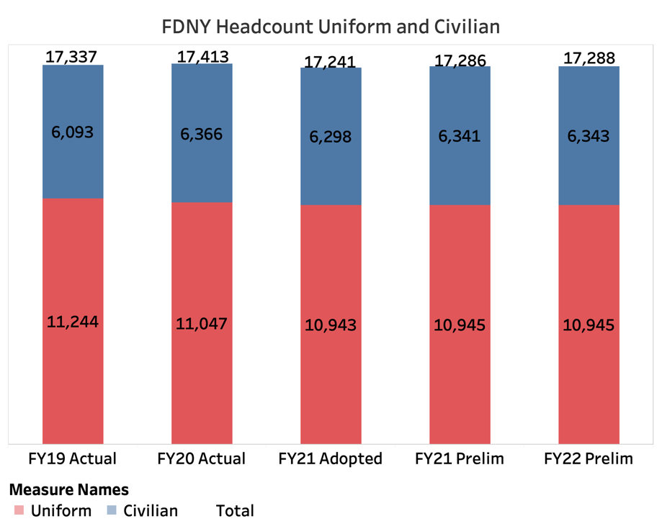
The Fire Department’s headcount is comprised mostly of firefighters and EMTs. The forecast for headcount adds 263 positions, nearly all civilian, through Fiscal 2025. The Department’s overall headcount remains primarily uniformed firefighters in the Fiscal 2022 Preliminary Budget 62 percent of the Department’s headcount in that group. The second largest group of employees are civilian EMS, with more than 4,300 positions, makes up 25 percent of the Department’s headcount. The remaining 13 percent is the rest of the Department, Fire Investigation, Fire Prevention, central administrative staff and more.
FDNY Headcount Uniform and Civilian
- Fly Car Program. The November 2020 Plan paused the Fly Car Pilot program in the Bronx and the planned expansion. The pilot had 60 positions associated, which have been reallocated within the Department, the 225 positions associated with the expansion had not been hired yet and does not impact current employees. The program is planned to resume in Fiscal 2023, and the positions will return.
- Mental Health Teams. As noted on page six, the Fiscal 2022 Preliminary Budget adds 21 positions to EMS in Fiscal 2021 and 2022 to operate the Mental Health Teams Pilot program.
- Headcount Adjustments. The November 2020 Plan added 81 positions in Fiscal 2021 and 80 positions in Fiscal 2022, reallocated across various budget codes and units of appropriation. However, with the many changes, there are no operational changes associated, the 81 and 80 additions align budgeted headcount with actual headcount.
- Class Reductions
  - The Department canceled a class with approximately 320 Fire Academy probies in April and May of 2020 due to the pandemic. The three upcoming classes, planned to start in March and September of 2021, will begin with approximately 150 probationary fire fighters due to social distancing measures, and March of 2022 will have a full 320 beginning class headcount.
  - The EMS Probationary Trainee Program graduated a class of 154 in February 2020, just before the pandemic began. Since the pandemic, a class of 153 probationary trainees graduated in October 2020. New classes are expected to begin in March and June of 2021 with 90 enrollees to the probationary Medical School and 60 to the FDNY Probationary Trainee Program, the only difference being that those in the EMS School will include a NYS EMT Certification Exam. Furthermore, 62 paramedics graduated in November of 2020, with 72-60 beginning the Medic Basic course in February of 2021.
COVID-19
The pandemic put stress on the emergency medical system and has had a significant impact on medical calls in Fiscal 2021. The number of medical calls peaked, with more than 6,900 calls on three separate days during the last week of March 2020, while the average for calendar year 2019 was approximately 4,150 calls. By June 2020 the average number of daily calls dropped to less than 3,700 daily. The subsequent reduction in life threatening medical calls can be attributable to individuals only calling 911 during a true emergency, and less traveling in the City. The reduction is clearly a trend in every borough, as seen in the chart below.

Over the course of the above chart the City needed to bring in additional ambulances to deal with the increased call volume. The National Ambulance Contract brought more than 350 ambulances from across the country, for April and May of 2020. Now with less calls and the same amount of resources as before the pandemic, call volume has decreased. This data shows there is a minimum amount of time it takes to respond to a medical emergency. In theory reduced calls should free up responders to get to emergencies faster. However, the volume of calls are not the only factor for response times, with dispatching, travel time, and other variables, response time are not easily changed. Refer to the chart below for additional details.

While EMS has experienced record high call volume, Fire Units continue to respond to structural and non-structural fires around the City. Some of the most dangerous fires are structural fires, the number of calls for structural fires have significantly decreased since the pandemic, as seen in the chart below.

As seen with life threatening medical emergencies, response times did not decrease with the corresponding call volume decrease. This data supports the idea that fire companies are not as impacted by call volume, and appropriate resources are given for the mission. Refer to the chart below for details.

Fiscal 2021 City Council Priorities
The Council annually supports the Fire Department through Capital projects. In Fiscal 2021, in three main categories.

Dollars in Millions | Prelim FY21 | Prelim FY22 | Prelim FY23 | Total
Vehicles and Equipment, Citywide | $0.2 | $1.9 | $0.4 | $2.5
Facility Improvements, Citywide | 1.2 | 4.1 | 0.7 | 6.1
FDNY Foundation | 0.4 | 0 | 0 | 0.4
Total | $1.8 | $6.0 | $1.1 | $8.9

The Fiscal 2022 Preliminary Budget shifted funding for Council-funded Capital projects out of Fiscal 2021 to the outyears: $4 million to Fiscal 2022 and $725,000 to Fiscal 2023. The total funding value did not change, and the Fiscal 2024 and 2025 figures were not altered.

Term and Condition
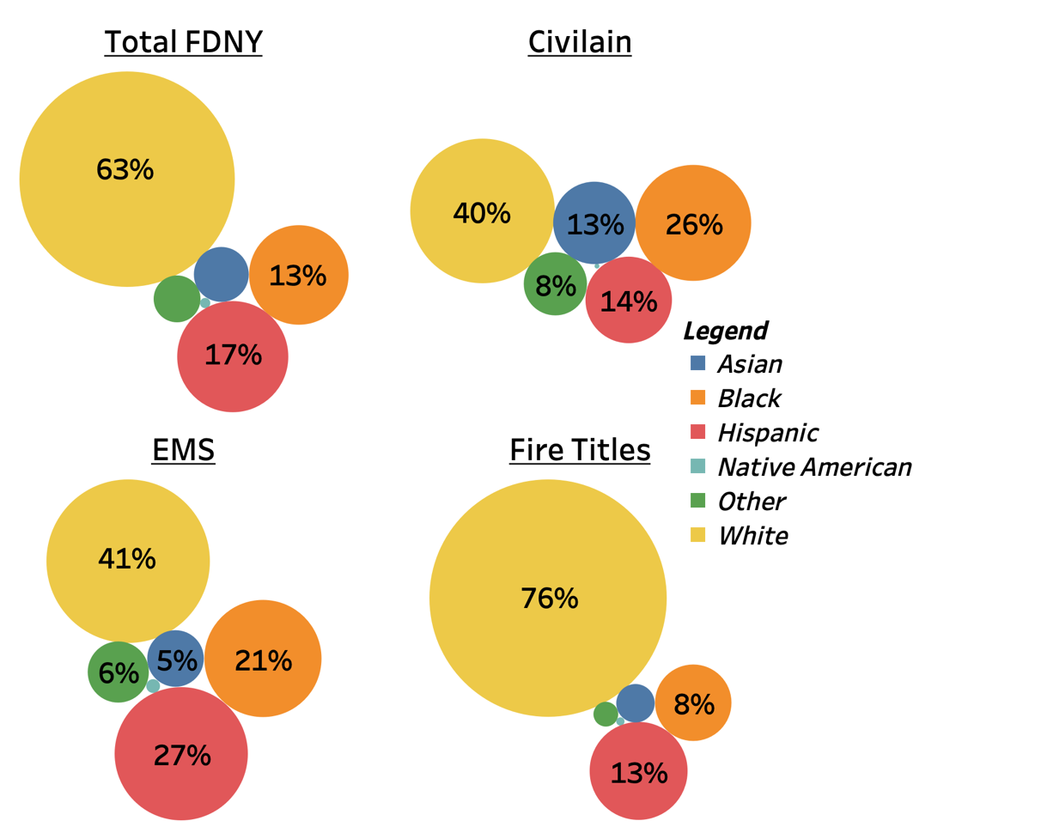
The City Council attached one term and condition to the Fire Department’s Fiscal 2021 Budget that requires the Department to report the demographics of its staff. In 2020, the Department’s Uniform Division was 99 percent male and 76 percent white. The civilian and EMS portions were much more diverse. The racial makeup is shown in the chart to the right. The Department’s racial makeup does not represent the racial makeup of the City.
Numbers not shown: Total FDNY: Asian 4%, Other, 3%, Native American 0.1%. Civilian: Native American 0.1%, EMS: Native American 0.3%. Fire Titles: Asian 2%, Other 0.8%, Native American 0.1%.
Historically, the Fire Department’s staff has been predominately male, and continues into Fiscal 2021. In the uniformed side of the Department women hold 125, or one percent of the 10,975 uniform positions. Of those 125, 69 women, or 55 percent, are monitories, compared to 2,544, or 23 percent of the 10,850 male uniformed members. The charts below highlight the gender breakdown by uniformed and EMS members. All data is as of October 2020.

FDNY Pay Rates
Number of Years | Fire | EMT | Paramedic
Starting | $43,904 | $35,254 | $48,237
After 1 Year | $46,066 | $37,250 | $53,135
After 2 Years | $50,173 | $37,914 | $55,302
After 3 Years | $55,192 | $43,901 | $61,005
After 4 Years | $60,837 | N/A | N/A
After 5 Years | $85,292 | $50,604 | $65,226
Average | $75,130 | $43,180 | $60,777
Average with Fringe | $199,917 | $65,573 | $92,013
Source: https://www.joinfdny.com/careers/firefighter/ February 2021, and FDNY for average figures.
Wages
As the lowest paid first responders in New York City, the Council has continually called for an increase in the salaries of EMS members. In May 2020 the Committee on Fire and Emergency Management, with the support of the majority of the Council recognized that EMS personnel in New York City should be compensated similar to firefighters and police officers.
During COVID-19, EMS personnel went through a traumatic and unparalleled increase in call volume and member illness. With record highs in call volume and members medical leave usage during the peak of the pandemic, the City saw the extreme lengths that EMS personnel go through, and their importance to the safety of New Yorkers. In New York City, the starting salary for an EMT is $35,254, $48,237 for a paramedic, and $43,904 for a firefighter, after five years a firefighter makes $85,292, $50,604 for an EMT, and $65,226 for a paramedic.
Using figures provided by the Fire Department, the average Emergency Medical Technician (EMT) makes $32,000 less than the average firefighter, and paramedics make $14,000 less compared to firefighters. When fringe benefits, including pensions, are factored in the average EMT earns $134,000 less and the average paramedic makes $108,000 less.
The average salary for each type of position would indicate that the average firefighter has been on staff for more than four years, while both EMTs and Paramedics for less than three.
The differing pay rates for uniformed and EMS staff create challenges for the Department, as many EMS staff apply for the promotion to firefighter exam. The attrition rates for EMS include resignations, retirements, and promotion to firefighter, not movement within EMS such as from EMT to paramedic. After a promotion to firefighter exam is offered, attrition rates for EMS significantly increase. The last exam was offered in December of 2016, with results posted on May 17, 2017. EMS attrition rates for the following years are skewed, reflecting in Fiscal 2018 was 20.6 percent, 13.2 percent in Fiscal 2019, 5.4 percent in Fiscal 2020, 5.28 percent so far in Fiscal 2021, with no promotions to firefighter this fiscal year. Over the same period attrition rates for uniformed members were 4.1 percent in Fiscal 2018, 4.6 percent in Fiscal 2019 and Fiscal 2020, and so far is 4.2 percent in Fiscal 2021. However, to average these together over the nearly four years, the EMS attrition rate is 11.1 percent while the uniformed attrition rate is 4.34 percent.
Overtime
The Fire Department relies on overtime to put out fires, respond to non-fire emergencies, and respond to medical emergencies, as seen during the height of COVID-19 in Fiscal 2020. With overtime being an integral part of Department functions, uniformed overtime expenditures have been steady over the past few years. The below charts describe the year-end actual spending for uniformed and EMS overtime.
Uniform overtime has been over $250 million for five years, but has remained fairly consistent after peaking in Fiscal 2017. Alternatively, EMS overtime has increased since Fiscal 2016, not remained flat. As call volume continues to increase for EMS, overtime funds should show the same progression.
*FY21 is Year to Date spending, *FY22 is Planned Spending as of the Preliminary Budget
While Fiscal 2020 was a year with high overtime spending, the Department had $130 million or 44 percent from non-city sources. Data on years prior to Fiscal 2020 overtime funding sources are not available, however due to COVID-19 related federal funding, 44 percent is likely greater than previous years.

*FY21 is Year to Date spending, *FY22 is Planned Spending as of the Preliminary Budget

Miscellaneous Revenue
Figure 1FY21 is Year to Date spending, FY22 is Planned Spending as of the Preliminary Budget
The Department generates Miscellaneous Revenue from two primary fees: Fire Inspection Fees and a two percent tax on fire insurance premiums. The FDNY issues permits and collects fees for inspection of fire suppression and electrical systems, places of public assembly, laboratories, high rise buildings, and storage and use of combustible materials. The Department also realizes revenue from fees charged to out-of-state fire insurers that issue policies in New York City, and private fire alarm companies that operate in New York City.
Miscellaneous Revenue has had its own challenges in the past year. Fire Inspection fees decreased due to COVID-19 and the lack of activity for public assembly and business closures. The Fiscal 2021 Adopted and November 2020 Plans led to Fiscal 2021 revenue decreasing from $69 million in the Fiscal 2021 Preliminary Budget to $53.2 million in the Fiscal 2022 Preliminary Budget. The outyears are not impacted as COVID-19 related shutdowns are not expected and revenue is expected to return to pre-pandemic levels. Fire Prevention Liens are planned to return to $3.6 million annually, a figure that had been increased in Fiscal 2019 because of higher-than-anticipated revenue.
FDNY Miscellaneous Revenue Budget Overview
Dollars in Millions
Revenue Sources | FY19 | FY20 | FY21 | Preliminary Plan |  |  | *Difference
 | Actual | Actual | Adopted | FY21 | FY22 | FY21-FY22
Private Alarm Co. Franchises | $1.2 | $1.4 | $1.2 | $1.2 | $1.2 | $0
2% Tax on Fire Insurance | 28.5 | 32.7 | 30.6 | 30.6 | 30.6 | 0
Fire Prevention Liens | 4.4 | 5.3 | 4.5 | 4.5 | 3.6 | (0.9)
Fire Inspection Fees | 64.7 | 60.2 | 59.7 | 53.2 | 68.1 | 8.4
Total | $98.7 | $99.6 | $96.0 | $89.5 | $103.5 | $7.5
The largest section of the miscellaneous revenue budget is from fire inspection fees. The Fire Inspector U/A has approximately 649 positions and a total budget of $46.2 million in the Fiscal 2022 Preliminary Budget. Even with a year that has less revenue than others, the Fire Inspection fees will cover the costs of the Fire Prevention U/A and generate additional revenue.

Fiscal 2021 Preliminary Mayor’s Management Report
The Mayor’s Office publishes the PMMR to highlight agency performance through the first four months of the fiscal year, monitoring specific items for each agency. The Fire Department has two service goals for reporting, first to protect lives and property from fire hazards and other emergencies, second, to repond to medical emergencies. Below are highlights from the Fiscal 2021 PMMR
Fire Hazards
- Structural and Non-Structural Fires. Through the first four months of Fiscal 2021 the number of structural fires has decreased by more than 650, or eight percent compared to Fiscal 2020. Conversely, the number of non-structural fires hasa increased by 438 or 11 percent in the same time period.
- Average End-to-End Response to Structural Fires. Response times to structural fires are an important indicator for the Department, showing the length of time from a caller dialing 911 to the first responders arriving the at the emergency. The Department has decreased the end-to-end response time to structural fires by three seconds to an average of 4:52 in the PMMR reporting period compared to Fiscal 2020.
- Risk-Based and Mandatory Inspections. The Department conducts risk-based and mandatory inspections on commercial and residential buildings. Risk based inspections are determined through analyses by the FDNY, while mandatory inspections are based on the fire code and policy requirements. Both types of inspections have decreased by 84 and 63 percent respectively, combined there were 27,500 less inspections compared to the first four months of Fiscal 2020. This is likely due to COVID-19 and the corresponding social distancing and work from business closures.
- Fire and Life Safety Education Presentations. Educational opportunities are used by the Department to encourage safe practices and decrease the number of fires in the City, among the many ways the FDNY educates New Yorkers is through presentations. The number of presentations in Fiscal 2021 has decreased by 92 percent or 2,961 to 241 presentations compared to Fiscal 2020. The Department has been following and enforcing COVID-19 social distancing regulations and likely can attribute the significant decrease to COVID-19.
Medical Emergencies
- Average Response Time to Life Threatening Medical Emergencies by Ambulances. A critical indicator for the Department, the time for an ambulance to respond to a life threatening emergency decreased by 50 seconds from 7:28 to 6:38 compared to the PMMR reporting period in Fiscal 2020. This metric was recorded in Fiscal 2020 before COVID-19, and may have declined due to fewer life threatening calls during the same period in Fiscal 2021.
- Peak Number of Ambulances in Service Per Day. The total number of medical response units available is an important indicator for availability of Units. Across all Advanced Life Support (ALS) Basic Life Support (BLS) and non-transport vehicles such as the recently suspended Fly Car program the Depratment has hundreds of vehicles in operation daily. During the first four months of Fiscal 2021 the peak number available is 512, greater than any number since the indicator has been reported in the MMR/PMMR in Fiscal 2013. As the Fly Car program was paused in the November 2020 Plan this figure could be slightly inflated, it is unclear whether the Department has deployed additional vehicles to supplement the service reduction from the fly car reduction.

Contract Budget
The City has 17,851 contracts and $17 billion in expenses for those contracts. The Fire Department makes up less than one percent of that figure, with $91.3 million across 226 different contracts. Since its Adopted Budget, the FDNY contract budget has decreased by $2 million or two percent. The Department’s contracts can be split into ten main categories, with highlights, the value and number of contracts outlined below.
- $62.6 million of the Department’s contracts support the Executive Administrative U/A, with data processing ($15.3 million), maintenance and repairs ($11.5 million), and general contractual services (17.5 million).
- The Fire Extinguishment and Emergency Response U/A holds $14.3 million in contracts, primarily for data processing and equipment, as well as maintenance and repairs and general contractual services.
- EMS also holds $14 million in contracts, mostly for general contractual services ($12.9 million) and maintenance and repairs ($1 million).
FDNY Contract Budget as of Fiscal 2022 Preliminary Budget
Type of Contract (Dollars in Thousands) | FY21 Adopted | # of Contracts | FY22 Preliminary | # of Contracts
Cleaning Services | $3,525 | 2 | $3,510 | 2
Contractual Services - General | 32,832 | 41 | 32,438 | 41
Data Processing Equipment Maintenance | 24,408 | 8 | 23,870 | 8
Maintenance | 17,612 | 156 | 17,612 | 156
Professional Services | 5,838 | 9 | 5,798 | 9
Security Services | 186 | 1 | 186 | 1
Telecommunications Maintenance | 758 | 2 | 755 | 2
Temporary Services | 7,828 | 2 | 6,833 | 2
Training Program for City Employees | 44 | 2 | 42 | 2
Transportation Services | 287 | 3 | 287 | 3
Total | $93,317 | 226 | $91,330 | 226

Dollars in Millions

Fiscal 2022-2025 Preliminary Capital Budget
The Fire Department of New York’s Fiscal 2022 Preliminary Capital Budget includes $607 million in Fiscal 2022-2025. FDNY’s Fiscal 2022 Preliminary Capital Budget is an estimate of the appropriations needed, in addition to the projected appropriations from Fiscal 2021, to fully fund the Department’s capital projects planned for next year. As of November 2020, FDNY had $185 million in available appropriations for Fiscal 2021.

Preliminary Capital Commitment Plan for Fiscal 2021-2025
The Fire Department of New York’s Preliminary Capital Commitment Plan includes $977 million in Fiscal 2021-2025. This represents approximately one percent of the City’s total $84.1 billion Preliminary Commitment Plan.

The Preliminary Capital Commitment Plan for the FDNY for Fiscal 2021-2025 has not changed in total value; instead, it has shifted nearly $25 million to Fiscal 2023 and 2025. Due to COVID-19, funds are lower and projects have been shifted to the outyears. Some projects are continuing while others that have not started are outright delayed, and some that have been started are being slowed.
For example, the Hurricane Sandy Conduit Project was pushed back but certain parts of the project are still funded in Fiscal 2021 and 2022, as the project relates to wellbeing and safety of New Yorkers.
FDNY Capital Commitments

2020 Preliminary Capital Commimtment Plan Major Projects:
- EMS Station 17. Originally announced on May 22, 2017, Mayor de Blasio and Commissioner Nigro outlined a $30 million investment, $17 million of capital, to a new facility in the Highbridge neighborhood of the Bronx. Built in 1898, the facility was originally constructed for an Engine Company, and the station needs significant alterations for more space to meet the needs of the Department. At the time of the announcement in 2017, the station held 18 Basic Life Support and Advanced Life Support Tours.
- Firehouse Renovations. Firehouse renovations is a lump sum of FDNY Capital funding for various capital projects. The fund exist specifically for funding new and existing projects that have yet to be determined by the Department. In this instance, funding was shifted out, $2.4 million in Fiscal 2022, and $11.3 million in Fiscal 2023 directly to the above project, EMS Station-17.
- New Firehouse – EC268. This plan shifts $15.9 million, $1.6 million from Fiscal 2021, and $14.3 million from Fiscal 2022, to Fiscal 2023 for replacing an existing firehouse in the Rockaways. The firehouse was damaged from Hurricane Sandy and will continue to serve the Rockaways.
Some Capital projects were paused during the pandemic; those that were paused are restarting in three phases, on January 24, 2021, February 24, 2021, and March 15, 2021. The Department had 24 projects paused, including the Fort Totten Infrastructure upgrade. Nine projects resumed in phase one, four in phase two, and 11 in phase three.

Preliminary Ten-Year Capital Strategy Fiscal 2022-2031
The City’s Ten-Year Strategy totals $118.8 billion (all funds), which is $1.9 billion larger than the $116.9 billion Fiscal 2020-2029 Ten-Year Strategy. FDNY’s Ten-Year Capital Strategy totals $1.3 billion, or one percent of the City’s total Strategy.

Fiscal 2022-2031 Preliminary Ten-Year Capital Strategy by Year
In this Plan, the Department added $92 and $95 million in Fiscal 2030 and 2031 respectively. Compared to current funding levels this is roughly half of annual Capital budget. Overall, the Department’s Capital strategy is front-loaded, peaking in Fiscal 2023 with more than $267 million, followed by a decline and tabling off in the outyears to values less than $100 million annually. Considering the year-end commitments of the past five fiscal years averaged $108.6 million, front loading with shifts of projects to the near outyears is a likely strategy for the Department to use its capital funds.

Ten-Year Capital Strategy
FDNY’s Ten-Year Strategy is distributed among four categories. The distribution of the funding has changed since the most recent Ten-Year Capital Strategy in Fiscal 2019. The Department’s total plan has grown $84.4 million or six percent. First, Vehicles and Firefighting Tools remains the largest category, with 44 percent of the funding, or $606 million, although decreased from 50 percent, or $646 million. In order to fight fires and respond to medical emergencies, the Department must maintain an adequate and reliable fleet of vehicles. Second, New Facilities and Renovations has undergone the largest change, adding more than $130 million in funding from 31 percent to 38 percent of the Capital funding. Third largest remains Electronics and Data Processing with nine percent, or $122 million of Capital funding, and lastly, Communications is the smallest with eight percent, or $110 million in funding.

Dollars in Millions

With the recent shift in adding more than $100 million to New Facilities and Renovations and decreasing Vehicles and Firefighting Tools, the Department is showing that existing resources are a priority. While vehicles and firefighting tools like ladders are important, EMS Station and Firehouse expansion is happening and by this funding realignment, will likely continue to happen, as well as improving existing stations.

Appendices

A: Budget Actions in the November and the Preliminary Plans
Dollars in Thousands | FY21 |  |  | FY22
 | City | Non-City | Total | City | Non-City | Total
FDNY Budget as of the Adopted FY21 Budget | $1,727,101 | $376,457 | $2,103,558 | $1,713,813 | $385,058 | $2,098,871
Other Adjustments
FY21 NOV
AMSEC1 FY21 INCREASE | $0 | $11 | $11 | $0 | $0 | $0
AUTO ARSON ROLL FROM FY20 | 0 | 84 | 84 | 0 | 0 | 0
City Fringe Adjustment | 0 | 0 | 0 | 2,000 | 0 | 2,000
Citywide Discretionary Training Freeze | (50) | 0 | (50) | 0 | 0 | 0
Citywide Wireless Services | 0 | 0 | 0 | (114) | 0 | (114)
CON Ed | 0 | 726 | 726 | 0 | 0 | 0
DEMAND FY21 INCREASE | 0 | 30 | 30 | 0 | 0 | 0
E005 | 0 | 1,103 | 1,103 | 0 | 0 | 0
EO12 | 0 | 7,385 | 7,385 | 0 | 0 | 0
E013 FY21 INCREASE | 0 | 53 | 53 | 0 | 0 | 0
Energy Personnel | 0 | 98 | 98 | 0 | 0 | 0
ExCEL Projects | 0 | 5 | 5 | 0 | 0 | 0
Federal Fringe Offset | 0 | 0 | 0 | 0 | (2,000) | (2,000)
FEMA Funding | 0 | 16,366 | 16,366 | 0 | 0 | 0
FIRSTW FY21 INCREASE | 0 | 740 | 740 | 0 | 0 | 0
FORESTRY FY21 INCREASE | 0 | 11 | 11 | 0 | 0 | 0
FY20 ASST TO FF / COVID-19 SUP | 0 | 7,826 | 7,826 | 0 | 0 | 0
FY20 FD TRAINING & CACHE MAINT | 0 | 57 | 57 | 0 | 0 | 0
FY21 DHS GRANT FRINGE | 0 | (2,000) | (2,000) | 0 | 2,000 | 2,000
GASKIT FY21 INCREASE | 0 | 4 | 4 | 0 | 0 | 0
Home 17 | 0 | 104 | 104 | 0 | 0 | 0
Home 18 | 0 | 1,299 | 1,299 | 0 | 0 | 0
Managerial and OJ Furloughs | (418) | (3) | (421) | 0 | 0 | 0
PSAP 2019-2020 AWARD | 0 | 59 | 59 | 0 | 0 | 0
SAMGRT FY21 INCREASE | 0 | 58 | 58 | 0 | 0 | 0
SHSG 17, 18, 19 | 0 | 5,847 | 5,847 | 0 | 0 | 0
SICG | 0 | 108 | 108 | 0 | 0 | 0
SICO18 FY21 INCREASE | 0 | 0 | 0 | 0 | 0 | 0
UASO 17 and 18 | 0 | 261 | 261 | 0 | 0 | 0
UASI 17, 18, 19 | 0 | 4,001 | 4,001 | 0 | 0 | 0
USAR 17 and 18 | 0 | 74 | 74 | 0 | 0 | 0
Subtotal, November | ($389) | $55,878 | $55,489 | $1,886 | $0 | $1,886
Other Adjustments Jan
CARES FUNDING VIA H + H | $0 | $6,134 | $6,134 | $0 | $0 | $0
City Fringe Adjustment | 1,897 | 0 | 1,897 | 4,108 | 0 | 4,108
Citywide Wireless Services | (68) | 0 | (68) | 0 | 0 | 0
EBOLA YEAR 5 INCREASE | 0 | 35 | 35 | 0 | 0 | 0
EMS MH Teams Transfer | 511 | 0 | 511 | 1,195 | 0 | 1,195
FDNY Q1 CERT Reimbursement | 0 | 19 | 19 | 0 |  | 0
Federal Fringe Offset | 0 | (1,897) | (1,897) | 0 | (4,108) | (4,108)
FY21 FDNY SRS | 0 | 534 | 534 | 0 | 0 | 0
Local Initiatives | 20 | 0 | 20 | 0 | 0 | 0
Office Supplies Spending | (35) | 0 | (35) | 0 | 0 | 0
Port 17, 18 and 19 Increase | 0 | 1,139 | 1,139 | 0 | 0 | 0
Printing Reduction | (117) | 0 | (117) | 0 | 0 | 0
SHSG 17, 18, 19 and 20 | 0 | 5,494 | 5,494 | 0 | 14,296 | 14,296
UASI 18, 19, 20 | 0 | 6,748 | 6,748 | 0 | 13,203 | 13,203
Subtotal, Jan | $2,208 | $18,207 | $20,415 | $5,304 | $23,391 | $28,694
Total, All Other Adjustments | $1,819 | $74,085 | $75,903 | $7,189 | $23,391 | $30,580

Dollars in Thousands | FY21 |  |  | FY22
 | City | Non-City | Total | City | Non-City | Total
Savings Program
Savings November
Fly Car Pilot | ($3,270) | $0 | ($3,270) | ($3,270) | $0 | ($3,270)
Fly Car Program | 0 | 0 | 0 | (13,626) | 0 | (13,626)
Fringe Savings | 0 | 0 | 0 | (2,000) | 0 | (2,000)
Hiring Freeze | (402) | 0 | (402) | (536) | 0 | (536)
Probationary Firefighter Class | (8,048) | 0 | (8,048) | 0 | 0 | 0
Training Savings | 0 | 0 | 0 | (2,500) | 0 | (2,500)
Subtotal, November Savings | ($11,720) | $0 | ($11,720) | ($21,932) | $0 | ($21,932)
Savings Jan
EMS Revenue Increase | ($14,500) | $14,500 | $0 | ($20,800) | $20,800 | $0
Grant Fringe | (1,897) | 0 | (1,897) | (4,108) | 0 | (4,108)
PS Savings | (5,935) | 0 | (5,935) | (11,871) | 0 | (11,871)
Subtotal, Jan Savings | ($22,332) | $14,500 | ($7,832) | ($36,779) | $20,800 | ($15,979)
Total, Savings Program | ($34,052) | $14,500 | ($19,552) | ($58,711) | $20,800 | ($37,911)
Total, Other Adjustments and Savings | ($32,233) | $88,585 | $56,352 | ($51,522) | $44,191 | ($7,331)
FDNY Budget as of the Fiscal 2022 Preliminary Budget | $1,694,869 | $465,041 | $2,159,910 | $1,662,291 | $429,249 | $2,091,540

B: FDNY Contract Budget
FDNY FY22 Preliminary Contract Budget
Dollars in Thousands
Category | FY21 Adopted | Number of Contracts | FY22 Preliminary | Number of Contracts
Cleaning Services | $3,525 | 2 | $3,510 | 2
Contractual Services - General | 32,832 | 41 | 32,438 | 41
Data Processing Equipment Maintenance | 24,408 | 8 | 23,870 | 8
Maintenance and Operation of Infrastructure | 2,596 | 24 | 2,596 | 24
Maintenance and Repairs - General | 12,772 | 97 | 12,772 | 97
Maintenance and Repairs - Motor Vehicle Equip | 2,244 | 35 | 2,244 | 35
Prof. Services - Computer Services | 4,839 | 2 | 4,799 | 2
Prof. Services - Direct Educational Services to Students | 15 | 1 | 15 | 1
Prof. Services - Legal Services | 135 | 1 | 135 | 1
Prof. Services - Other | 849 | 5 | 849 | 5
Security Services | 186 | 1 | 186 | 1
Telecommunications Maintenance | 758 | 2 | 755 | 2
Temporary Services | 7,828 | 2 | 6,833 | 2
Training Program for City Employees | 44 | 2 | 42 | 2
Transportation Services | 287 | 3 | 287 | 3
Total | $93,317 | 226 | $91,330 | 226

C: Program Areas

Fire Extinguishment/Emergency Response
Fire Extinguishment/Emergency Response
Dollars in Thousands
 | FY19 | FY20 | FY21 | Preliminary Plan |  | *Difference
 | Actual | Actual | Adopted | FY21 | FY22 | FY21-FY22
Spending
Personal Services
Full-Time Salaried - Uniformed | $917,448 | $922,693 | $982,976 | $948,591 | $959,462 | ($23,514)
Full-Time Salaried - Civilian | 16,932 | 16,857 | 15,852 | 16,009 | 15,709 | (143)
Overtime - Uniformed | 255,258 | 247,434 | 203,993 | 221,297 | 212,083 | 8,090
Overtime - Civilian | 3,185 | 3,383 | 2,839 | 2,858 | 2,839 | 0
Fringe Benefits | 14,605 | 17,918 | 19,752 | 18,047 | 18,805 | (947)
Additional Gross Pay | 166,274 | 169,241 | 173,921 | 176,521 | 176,403 | 2,482
Subtotal | $1,373,702 | $1,377,526 | $1,399,333 | $1,383,324 | $1,385,302 | ($14,031)
Other Than Personal Services
Supplies and Materials | $7,854 | $7,274 | $7,134 | $6,674 | $7,134 | $0
Property and Equipment | 6,141 | 3,984 | 1,627 | 3,176 | 1,627 | 0
Other Services and Charges | 1,243 | 1,206 | 1,455 | 2,130 | 1,455 | 0
Contractual Services | 12,193 | 12,905 | 14,239 | 13,698 | 14,301 | 62
Subtotal | $27,431 | $25,370 | $24,455 | $25,678 | $24,517 | $62
Total | $1,401,134 | $1,402,896 | $1,423,788 | $1,409,002 | $1,409,818 | ($13,969)
Funding
City Funds |  |  | $1,409,188 | $1,351,390 | $1,344,969 | ($64,218)
Federal - Other |  |  | 9,959 | 18,147 | 9,306 | (653)
Intra-City |  |  | 0 | 76 | 0 | 0
Other Categorical |  |  | 3,652 | 38,340 | 54,553 | 50,902
State |  |  | 989 | 1,048 | 989 | 0
Total | $1,401,134 | $1,402,896 | $1,423,788 | $1,409,002 | $1,409,818 | ($13,969)
Budgeted Headcount
Full-Time Positions - Uniform | 11,026 | 10,840 | 10,737 | 10,737 | 10,737 | 0
Full-Time Positions - Civilian | 287 | 281 | 277 | 308 | 308 | 31
Total | 11,313 | 11,121 | 11,014 | 11,045 | 11,045 | 31
*The difference of Fiscal 2021 Adopted Budget compared to Fiscal 2022 Preliminary Budget

Emergency Medical Services
Emergency Medical Services
Dollars in Thousands
 | FY19 | FY20 | FY21 | Preliminary Plan |  | *Difference
 | Actual | Actual | Adopted | FY21 | FY22 | FY21-FY22
Spending
Personal Services
Full-Time Salaried - Uniformed | $230 | $235 | $232 | $228 | $232 | $0
Full-Time Salaried - Civilian | 213,025 | 221,638 | 235,283 | 232,448 | 233,968 | (1,315)
Overtime - Uniformed | $1 | 0 | 0 | 0 | 0 | 0
Overtime - Civilian | 57,563 | 55,707 | 30,589 | 30,741 | 29,543 | (1,046)
Fringe Benefits | 551 | 546 | 904 | 904 | 904 | 0
Additional Gross Pay | 26,577 | 27,332 | 26,167 | 26,167 | 26,167 | 0
Subtotal | $297,947 | $305,458 | $293,175 | $290,487 | $290,815 | ($2,361)
Other Than Personal Services
Supplies and Materials | $13,888 | $16,738 | $15,180 | $14,491 | $15,716 | $535
Property and Equipment | 2,787 | 4,571 | 3,026 | 2,480 | 2,399 | (627)
Other Services and Charges | $3,535 | 3,499 | 4,107 | 5,556 | 4,152 | 46
Contractual Services | 13,250 | 12,175 | 14,327 | 14,126 | 14,071 | (256)
Subtotal | $33,460 | $36,983 | $36,639 | $36,652 | $36,337 | ($302)
Total | $331,407 | $342,441 | $329,815 | $327,140 | $327,152 | ($2,663)
Funding
City Funds |  |  | $6,148 | $23,428 | $5,487 | ($661)
Federal - Other |  |  | 0 | 162 | 0 | 0
Other Categorical |  |  | 323,652 | 303,535 | 321,650 | (2,002)
State |  |  | 846 | 846 | 846 | 0
Total | $331,407 | $342,441 | $330,646 | $327,971 | $327,983 | ($2,663)
Budgeted Headcount
Full-Time Positions - Uniform | 2 | 1 | 1 | 1 | 1 | 0
Full-Time Positions - Civilian | 4,175 | 4,406 | 4,368 | 4,333 | 4,333 | (35)
Total | 4,177 | 4,407 | 4,369 | 4,334 | 4,334 | (35)
*The difference of Fiscal 2021 Adopted Budget compared to Fiscal 2022 Preliminary Budget.

Executive Administrative
Executive Administrative
Dollars in Thousands
 | FY19 | FY20 | FY21 | Preliminary Plan |  | *Difference
 | Actual | Actual | Adopted | FY21 | FY22 | FY21-FY22
Spending
Personal Services
Full-Time Salaried - Uniformed | $3,815 | $4,132 | $4,589 | $4,892 | $5,540 | $951
Full-Time Salaried - Civilian | 88,935 | 96,742 | 95,922 | 94,669 | 93,887 | (2,035)
Overtime - Uniformed | 286 | 65 | 4,680 | 4,807 | 4,807 | 127
Overtime - Civilian | 14,106 | 15,070 | 4,383 | 4,408 | 4,409 | 26
Fringe Benefits | 793 | 944 | 3,534 | 3,264 | 1,517 | (2,017)
Additional Gross Pay | 10,156 | 10,294 | 8,058 | 8,150 | 8,180 | 122
Subtotal | $118,092 | $127,246 | $121,167 | $120,191 | $118,341 | ($2,826)
Other Than Personal Services
Supplies and Materials | $31,966 | $50,097 | $21,528 | $30,669 | $21,013 | ($516)
Fixed and Misc. Charges | 1,008 | 1,339 | 635 | 729 | 495 | (140)
Property and Equipment | 18,054 | 27,614 | 2,113 | 19,324 | 2,108 | (4)
Other Services and Charges | 54,014 | 58,327 | 69,418 | 101,663 | 79,591 | 10,173
Contractual Services | 81,261 | 89,307 | 64,433 | 80,246 | 62,640 | (1,792)
Subtotal | $186,303 | $226,684 | $158,127 | $232,631 | $165,847 | $7,721
Total | $304,395 | $353,931 | $279,293 | $352,823 | $284,188 | $4,895
Funding
City Funds |  |  | $241,940 | $250,560 | $242,290 | $350
Other Categorical |  |  | 0 | 1,436 | 0 | 0
Capital- IFA |  |  | 567 | 564 | 567 | 0
Federal - Other |  |  | 36,786 | 99,993 | 41,331 | 4,545
Intra-City |  |  | 0 | 104 | 0 | 0
State |  |  | 0 | 166 | 0 | 0
Total | $304,395 | $353,931 | $279,293 | $352,823 | $284,188 | $4,895
Budgeted Headcount
Full-Time Positions - Uniform | 29 | 29 | 42 | 44 | 44 | 2
Full-Time Positions - Civilian | 1,051 | 1,084 | 1,014 | 1,073 | 1,075 | 61
Total | 1,080 | 1,113 | 1,056 | 1,117 | 1,119 | 63
*The difference of Fiscal 2021 Adopted Budget compared to Fiscal 2022 Preliminary Budget.

Fire Prevention
Fire Prevention
Dollars in Thousands
 | FY19 | FY20 | FY21 | Preliminary Plan |  | *Difference
 | Actual | Actual | Adopted | FY21 | FY22 | FY21-FY22
Spending
Personal Services
Full-Time Salaried - Civilian | $2,523 | $2,152 | $3,653 | $3,791 | $3,823 | $170
Full-Time Salaried - Uniformed | 36,468 | 38,130 | 37,775 | 36,557 | 36,587 | (1,188)
Overtime - Uniformed | 496 | 392 | 107 | 710 | 176 | 69
Overtime – Civilian | 5,712 | 5,559 | 1,926 | 1,926 | 1,926 | 0
Fringe Benefits | 50 | 65 | 55 | 73 | 55 | 0
Additional Gross Pay | 2,431 | 1,990 | 1,632 | 1,657 | 1,657 | 24
Subtotal | $47,680 | $48,287 | $45,149 | $44,714 | $44,224 | ($925)
Other Than Personal Services
Supplies and Materials | $1,318 | $504 | $1,354 | $981 | $1,354 | $0
Property and Equipment | 66 | 61 | 6 | 6 | 6 | 0
Other Services and Charges | 251 | 366 | 306 | 554 | 306 | 0
Contractual Services | 857 | 961 | 318 | 443 | 318 | 0
Subtotal | $2,493 | $1,893 | $1,984 | $1,984 | $1,984 | $0
Total | $50,173 | $50,180 | $47,133 | $46,698 | $46,208 | ($925)
Funding
City Funds |  |  | $47,127 | $46,158 | $46,203 | ($925)
Intra-City |  |  | 6 | 540 | 6 | 0
Total | $50,173 | $50,180 | $47,133 | $46,698 | $46,208 | ($925)
Budgeted Headcount
Full-Time Positions - Uniform | 20 | 16 | 27 | 27 | 27 | 0
Full-Time Positions - Civilian | 575 | 590 | 634 | 622 | 622 | (12)
Total | 595 | 606 | 661 | 649 | 649 | (12)
*The difference of Fiscal 2021 Adopted Budget compared to Fiscal 2022 Preliminary Budget.

Fire Investigation
Fire Investigation
Dollars in Thousands
 | FY19 | FY20 | FY21 | Preliminary Plan |  | *Difference
 | Actual | Actual | Adopted | FY21 | FY22 | FY21-FY22
Spending
Personal Services
Full-Time Salaried - Uniformed | $16,883 | $16,336 | $16,422 | $16,555 | $16,643 | $221
Full-Time Salaried - Civilian | 307 | 318 | 331 | 331 | 332 | 1
Overtime - Uniformed | 4,988 | 4,198 | 2,763 | 2,937 | 2,853 | 89
Overtime - Civilian | 26 | 14 | 33 | 33 | 33 | 0
Fringe Benefits | 511 | 564 | 457 | 536 | 457 | $
Additional Gross Pay | 3,235 | 2,808 | 2,542 | 2,874 | 2,874 | 332
Subtotal | $25,950 | $24,238 | $22,549 | $23,267 | $23,192 | $643
Other Than Personal Services
Supplies and Materials | $125 | $91 | $126 | $124 | $126 | $0
Property and Equipment | 68 | 41 | 10 | 10 | 10 | 0
Other Services and Charges | 0 | 0 | 14 | 14 | 14 | 0
Contractual Services | 1 | 0 | 0 | 2 | 0 | 0
Subtotal | $194 | $133 | $150 | $150 | $150 | $0
Total | $26,144 | $24,370 | $22,699 | $23,417 | $23,342 | $643
Funding
City Funds |  |  | $22,699 | $23,332 | $23,342 | $643
State |  |  | 0 | 84 | 0 | 0
Total | $26,144 | $24,370 | $22,699 | $23,417 | $23,342 | $643
Budgeted Headcount
Full-Time Positions - Uniform | 167 | 161 | 136 | 136 | 136 | 0
Full-Time Positions - Civilian | 5 | 5 | 5 | 5 | 5 | 0
Total | 172 | 166 | 141 | 141 | 141 | 0
*The difference of Fiscal 2021 Adopted Budget compared to Fiscal 2022 Preliminary Budget.

https://www1.nyc.gov/assets/omb/downloads/pdf/jan21-bfa.pdf
Data from COVID-19 Senior Leadership Brief from June 1, 2020 to June 30, 2020.
https://legistar.council.nyc.gov/LegislationDetail.aspx?ID=4146331&GUID=6E165905-EC68-4D4B-9B08-BE4D480E42C2&Options=&Search=

