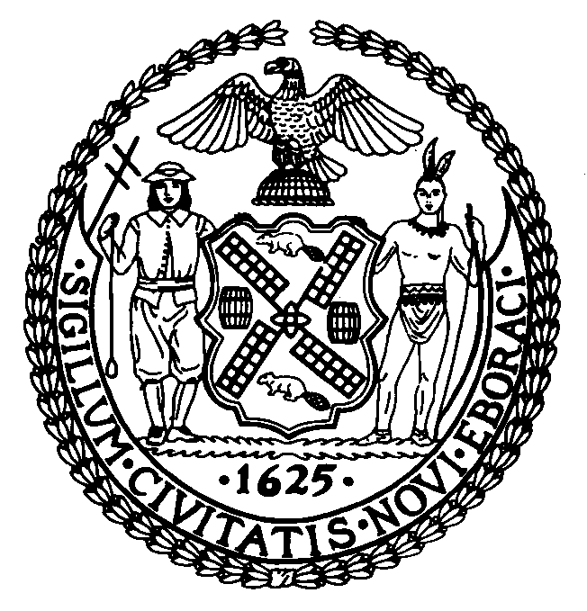
New York City Council Discretionary
Fiscal Year 2019
CERTIFICATION OF AUTHORIZATION TO SUBMIT AND APPLICATION COMPLETENESS

I certify that:

• I am authorized by the organization seeking funding to complete and submit this request for funding on behalf of the organization;

• I took reasonable steps to make sure that the information on this form is complete, true and accurate.

I understand that it is a crime to knowingly submit a request for funding that contains or may contain false information. I understand that violators are subject to prosecution.

Authorized Official: Signature Date

Authorized Official: Print Name Title

Legal Name of Organization

____________________________________________________________________________________
Federal Employee Identification Number (FEIN/EIN)

Sworn to before me this day of , 20

Notary Public

