Fiscal 2017 Term and Condition
New York City Health + Hospitals – Utilization Rates
New York City Health + Hospitals (H+H) provided a report on the hospital utilization rate of beds and the average length of stay, in total and disaggregated by hospital, on May 18, 2017.

- In fiscal year-ending 2016, H+H’s 11 acute hospitals had an average daily census of 3,617 individuals, with an overall average length of stay of 6.7 days. Its 4,613 beds had an average occupancy rate of 77.2 percent.
- H+H’s five skilled nursing facilities (SNF) had a combined average daily census of 1,849 individuals, with an overall average length of stay of 338 days. Its 2,017 beds had an average occupancy rate of 90.7 percent.

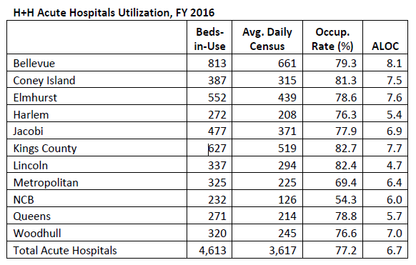
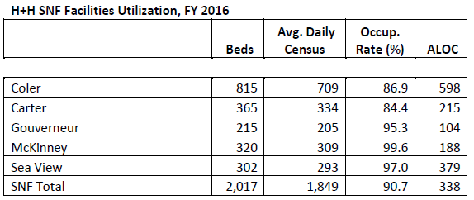
Health and Hospitals Corporation (819)
Unit of Appropriation [001]

As a condition of the funds in unit of appropriation number 001, the Health and Hospitals Corporation shall submit to the Council, no later than December 31, 2016, a report on the hospital utilization rate of beds and the average length of stay, in total and disaggregated by hospital.

If you have any questions, please contact Jeanette Merrill at JMerrill@council.nyc.gov

